华社首办 马来西亚依斯干达特区研讨会节目表
Program of 1st Community-Initiated Iskandar Malaysia Conference(CIMC1)
26th Oct. 2013 (Saturday)
时间  Time | 主题  Topic/Session | 主讲者/主持人  Distinguished Speakers/Guests
8:00am | 入场登记  Registration
9:00am  (15min) | 致欢迎词 Welcome Address
9:15am  (30min) | 主题演讲  Keynote Speech | 依斯干达发展局执行总裁  DatukIsmail Ibrahim  Chief Executive  Iskandar Regional Development Authority (IRDA)
9:45am  (40min) | 依斯干达发展进程及社会变迁  Iskandar Malaysia Updates:  Roadmap, Social Development & Moving Forward | 依斯干达发展局社会发展部主任  Nor Hisham Hussein  Head of Social Development  Iskandar Regional Development Authority (IRDA)
10:25am  (40min) | 新山大城市转型计划  Johor Bahru Transformation Plan | 依斯干达发展局规划与合规部主任  Puan Maimunah Jaafar  Head of Planning & Compliance  Iskandar Regional Development Authority (IRDA)
11:05am  (15min) | 茶点与交流时间Break& Networking
11:20am  (40min) | 依斯干达特区教育发展  EduCity@Iskandar | 依斯干达投资有限公司代表  Rep from Iskandar Investment Berhad (IIB)
12:00pm  (30min) | MEDINI：特区中的特区  Medini – The Pulse of Iskandar Malaysia | 拿督苏启志Dato’Soo Kai Chee  MCT 执行董事  Executive Director  Financial, Commercial & Marketing, MCT
12:30pm  (60min) | 特备午餐：交流时间 Lunch & Networking  ( Exhibition By:  Iskandar Community Development Division , And  by Sponsors )
1.30pm  (40min) | “人财资本”：大马人与国际人材  Optimising Malaysian Talent and Facilitating Global Talents | Mr. Siva Kumeren  Head of Foreign Talent Facilitation  TalentCorp Malaysia
2.10pm  (50min) | 大会综合讨论（一）  Panel Discussion I:  外国人看依斯干达  Foreign Investors’ Views of Iskandar | Moderator:  Dr. Wong Kim Hock  - Rep from Singapore  - Rep from China  - Mr Keith Martin, CEO of Inspired Partnerships Asia Consulting (iPAc Group)
3.00pm  (15min) | 茶点与交流时间 Break& Networking
3:15pm  (30min) | 华社与华商的机会与挑战  Opportunities & Challenges in Iskandar | - 新山中华工商总会会长拿督罗烈贤  Dato’ Loh Liam Hiang,  President, JBChinese Chamber  of Commerce and Industry (JBCCCI)  - 马来西亚中小企业工会会长郑己胜  Mr. The Kee Sin  President, SMI Association of Malaysia
3:45pm  (60min) | 特区产业：  太迟, 太热了吗？  Property Outlook in Iskandar | - 吕江禾先生 Mr. Loo Kung Hoe  柔佛Rahim & Co. 董事  Director of Rahim & Co. – Johor Branch  - Mr. Ishmael Ho  何振顺研究 特别计划经理  南洋商报产业特辑市场分析师  Special Project Manager  Ho Chin Soon Research
4:45pm  (60min) | <大会综合讨论（二）>  - 华社  - 华商  - 新新关系  - 教育  Panel Discussion II:  Iskandar – Moving Forward | Moderator主持人：  郑丁贤先生 Mr.Tay Tian Yan  星洲日报副执行总编辑  Deputy Executive Editor in Chief  Panel List：  - 拿督罗烈贤 Dato’ Loh Liam Hiang, President of Johor Bahru Chinese Chamber of Commerce and Industry (JBCCCI)  - 林奕钦会长Mr Lim Ik Kim, President of Johor BahruTiong-Hua Chinese Association  - 吕江禾Mr Loo Kung Hoe,  Director of Rahim & Co. – Johor Branch  - Dr. Thock Kiah Wah, President of Southern University College祝家华博士  - 其他人选
5:45pm | End of Conference

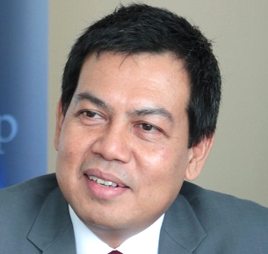 | Datuk Ismail Ibrahim  Chief Executive  Iskandar Regional Development Authority (IRDA)
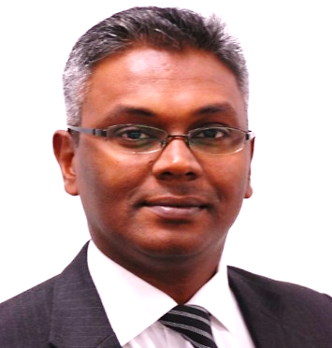 | Siva Kumeren  Head of Foreign Talent Facilitation  TalentCorporation Malaysia Berhad  (TalentCorp)
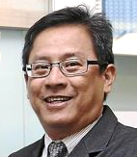 | Dato’ Soo Kai Chee  Executive Director  Financial, Commercial & Marketing  MCT Group
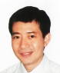 | Loo Kung Hoe  Director  Registered Valuer & Estate Agent  Rahim & Co. – Johor Branch
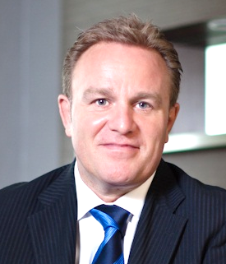 | Keith Martin  CEO  Inspired Partnerships Asia Consulting  (iPAc Group)

